Homework for week 1, submission deadline 23:59 on Sunday night.
1. Complete an Omics-to-Question map: Using your own research project or biological interest. What kind of omics you plan to use to solve the biological research question?
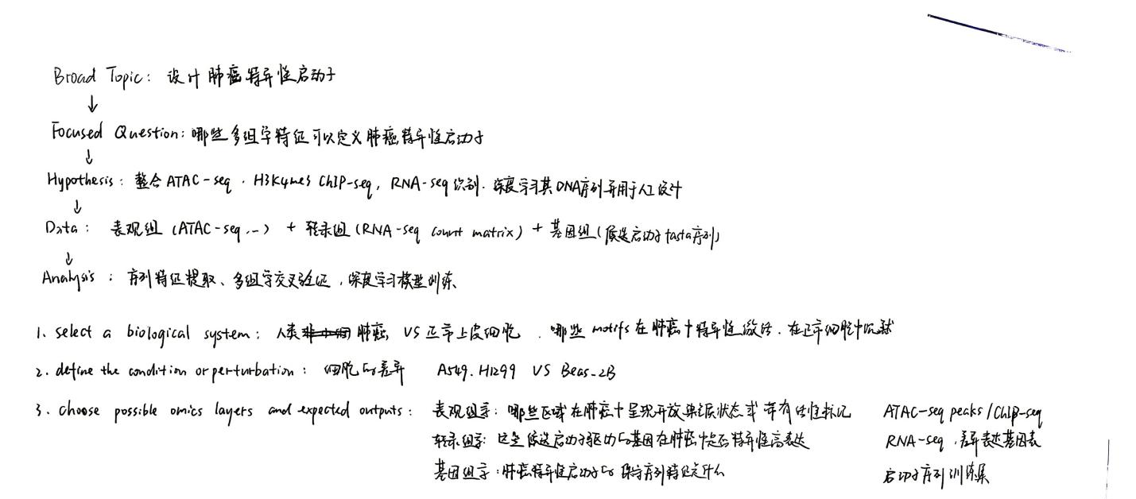
2. Write one weak prompt and one CARE+V prompt: For the same biological or research question, propose a weak and strong (CARE+V) prompt that can be tested by AI. Use any LLMs to test your prompt and paste the output results below.
Weak prompt:
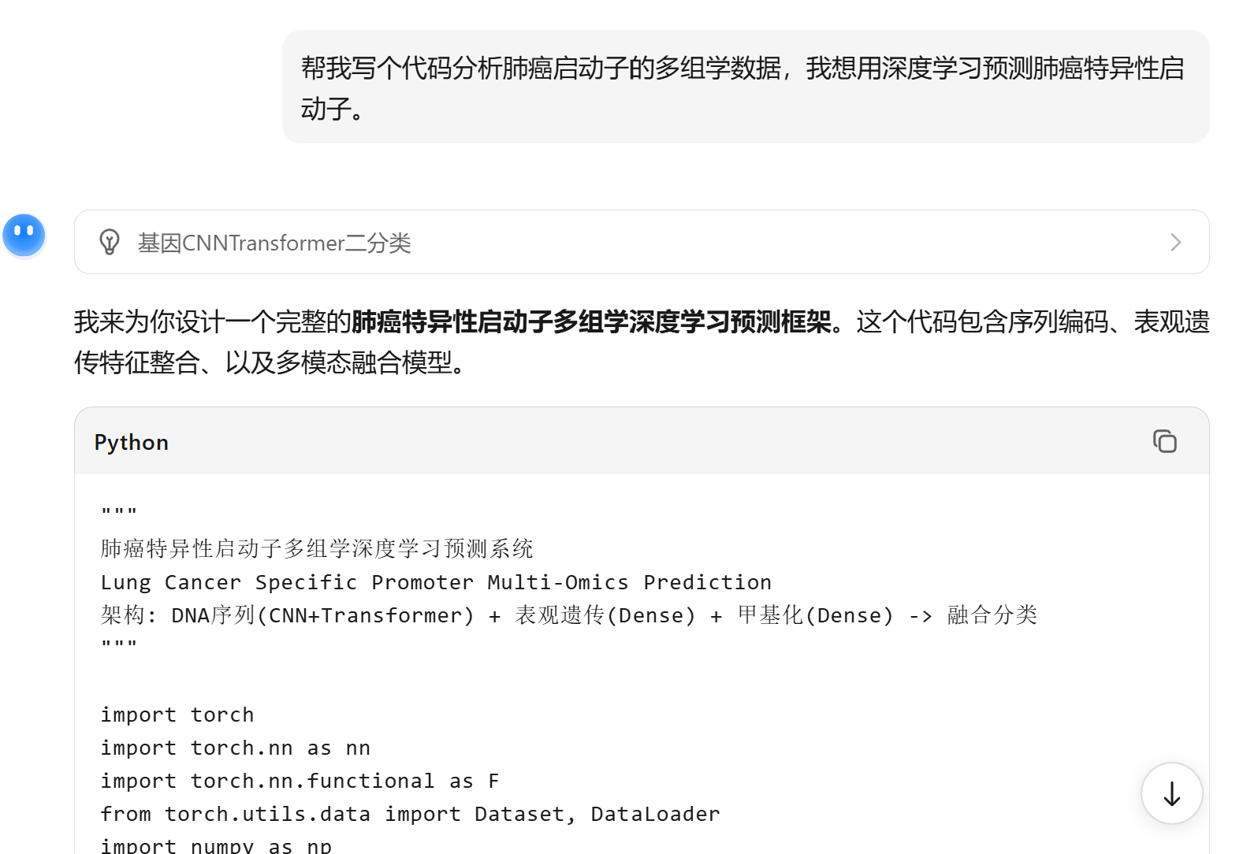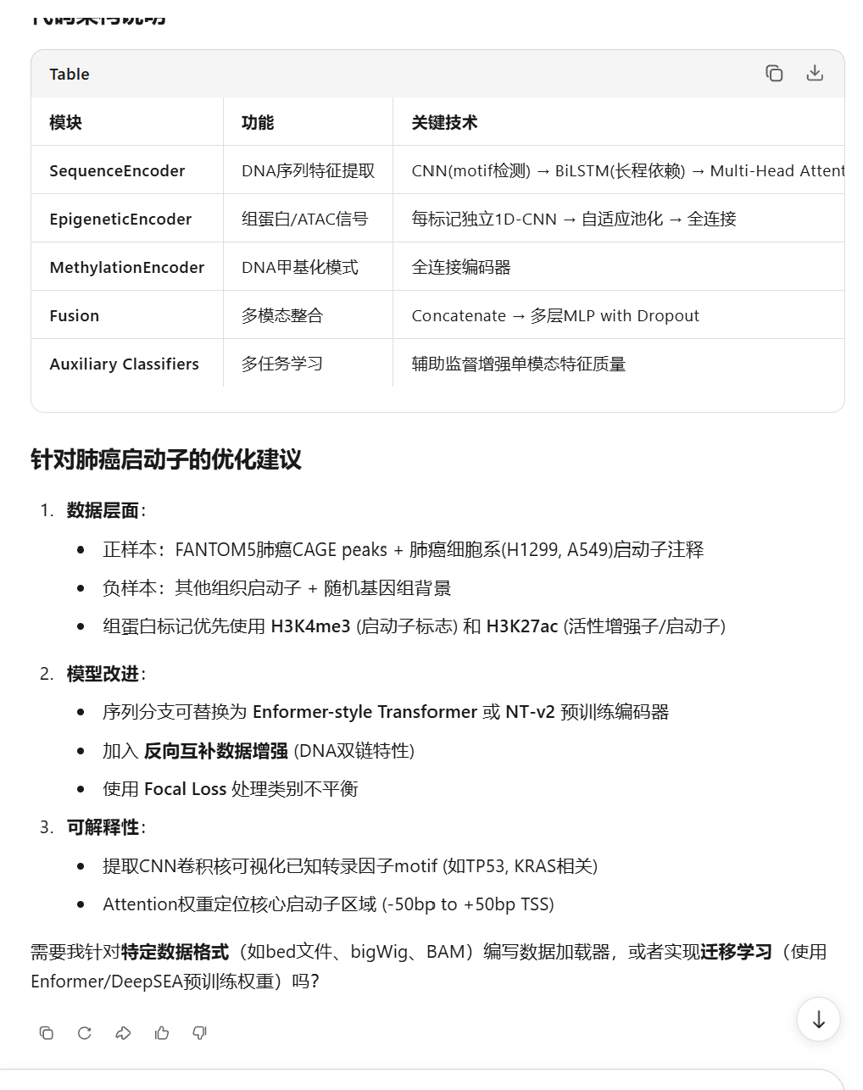
CARE+Vprompt:
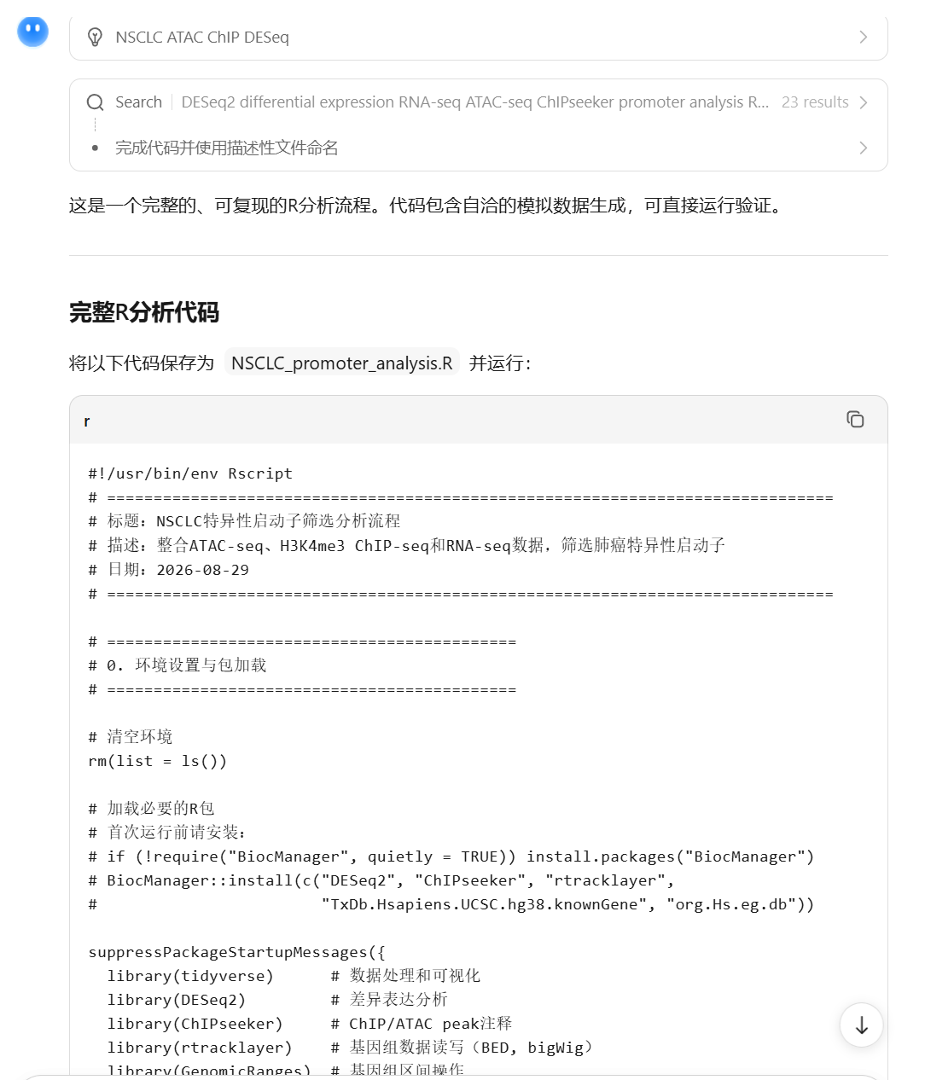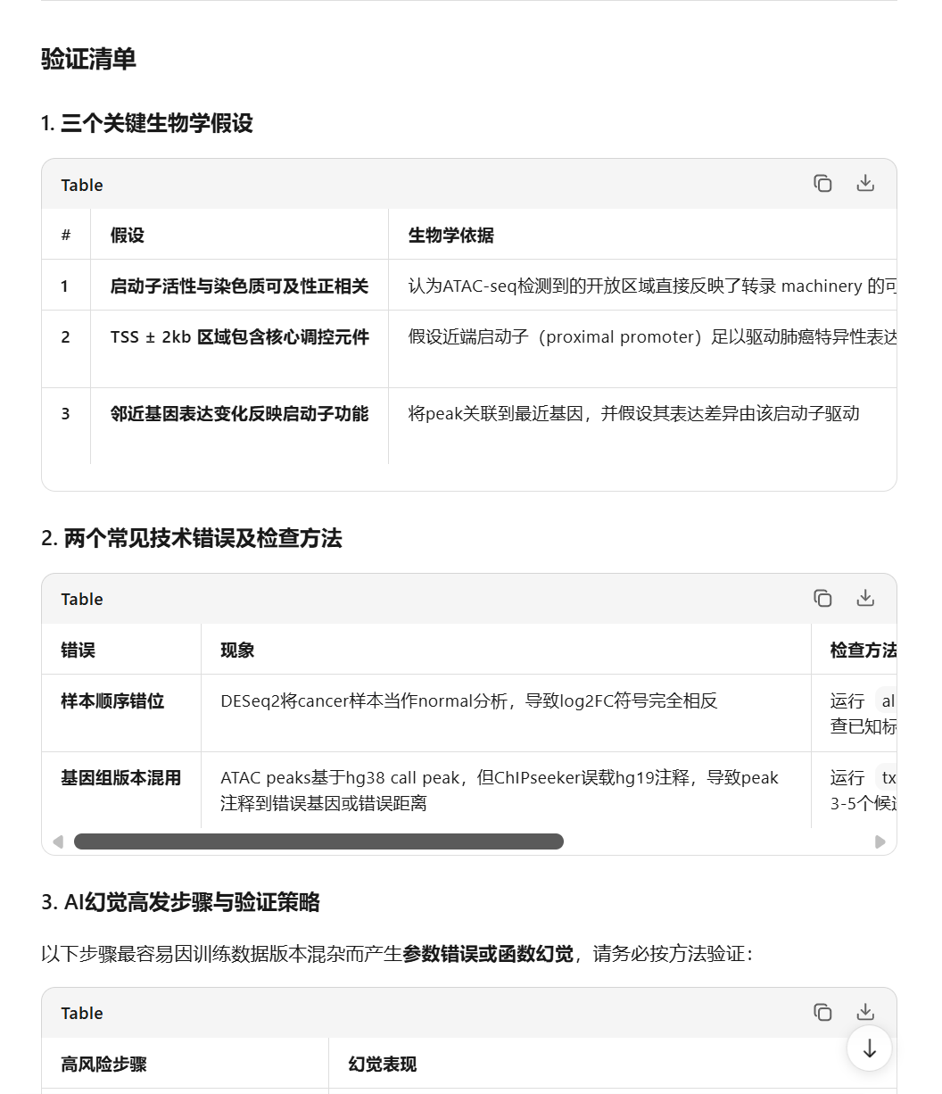

3. Install and Run R and RStudio and save output showing R version and packages.
R: https://cran.r-project.org/ RStudio: https://posit.co/products/open-source/rstudio.
Once installation, please paste a screen cut of Rstudio here. Give a try of R to using the foler (Week1_R_RStudio_Practice_Files) code and data.
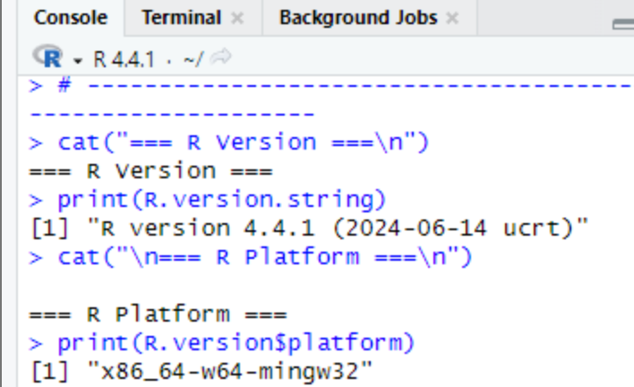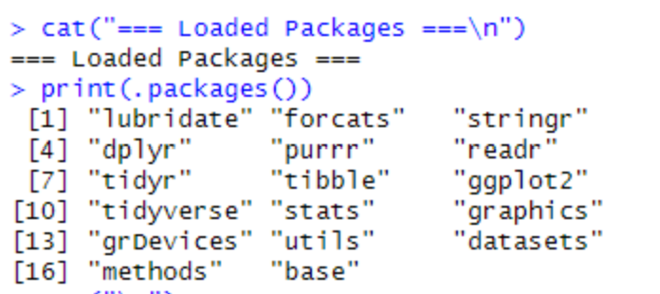
sessionInfo()R version 4.4.1 (2024-06-14 ucrt)
Platform: x86_64-w64-mingw32/x64
Running under: Windows 11 x64 (build 26200)

Matrix products: default

locale:
[1] LC_COLLATE=Chinese (Simplified)_China.utf8
[2] LC_CTYPE=Chinese (Simplified)_China.utf8
[3] LC_MONETARY=Chinese (Simplified)_China.utf8
[4] LC_NUMERIC=C
[5] LC_TIME=Chinese (Simplified)_China.utf8

time zone: Etc/GMT-8
tzcode source: internal

attached base packages:
[1] stats graphics grDevices
[4] utils datasets methods
[7] base

other attached packages:
[1] lubridate_1.9.4 forcats_1.0.0
[3] stringr_1.5.2 dplyr_1.1.4
[5] purrr_1.1.0 readr_2.1.6
[7] tidyr_1.3.1 tibble_3.3.0
[9] ggplot2_4.0.1 tidyverse_2.0.0

loaded via a namespace (and not attached):
[1] bit_4.6.0
[2] gtable_0.3.6
[3] crayon_1.5.3
[4] compiler_4.4.1
[5] tidyselect_1.2.1
[6] parallel_4.4.1
[7] textshaping_1.0.3
[8] systemfonts_1.2.3
[9] scales_1.4.0
[10] yaml_2.3.10
[11] fastmap_1.2.0
[12] R6_2.6.1
[13] labeling_0.4.3
[14] generics_0.1.4
[15] knitr_1.50
[16] pillar_1.11.0
[17] RColorBrewer_1.1-3
[18] tzdb_0.5.0
[19] rlang_1.1.6
[20] utf8_1.2.6
[21] stringi_1.8.7
[22] xfun_0.52
[23] S7_0.2.0
[24] bit64_4.6.0-1
[25] timechange_0.3.0
[26] cli_3.6.5
[27] withr_3.0.2
[28] magrittr_2.0.3
[29] digest_0.6.37
[30] grid_4.4.1
[31] vroom_1.6.5
[32] rstudioapi_0.17.1
[33] hms_1.1.3
[34] lifecycle_1.0.4
[35] vctrs_0.6.5
[36] evaluate_1.0.5
[37] glue_1.8.0
[38] farver_2.1.2
[39] ragg_1.5.0
[40] rmarkdown_2.29
[41] tools_4.4.1
[42] pkgconfig_2.0.3
[43] htmltools_0.5.8.1
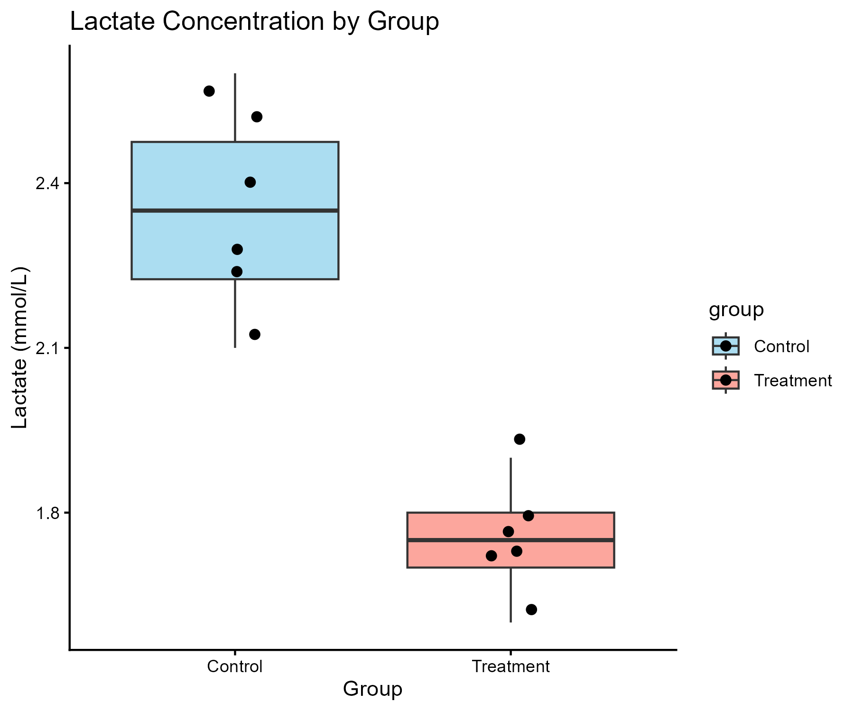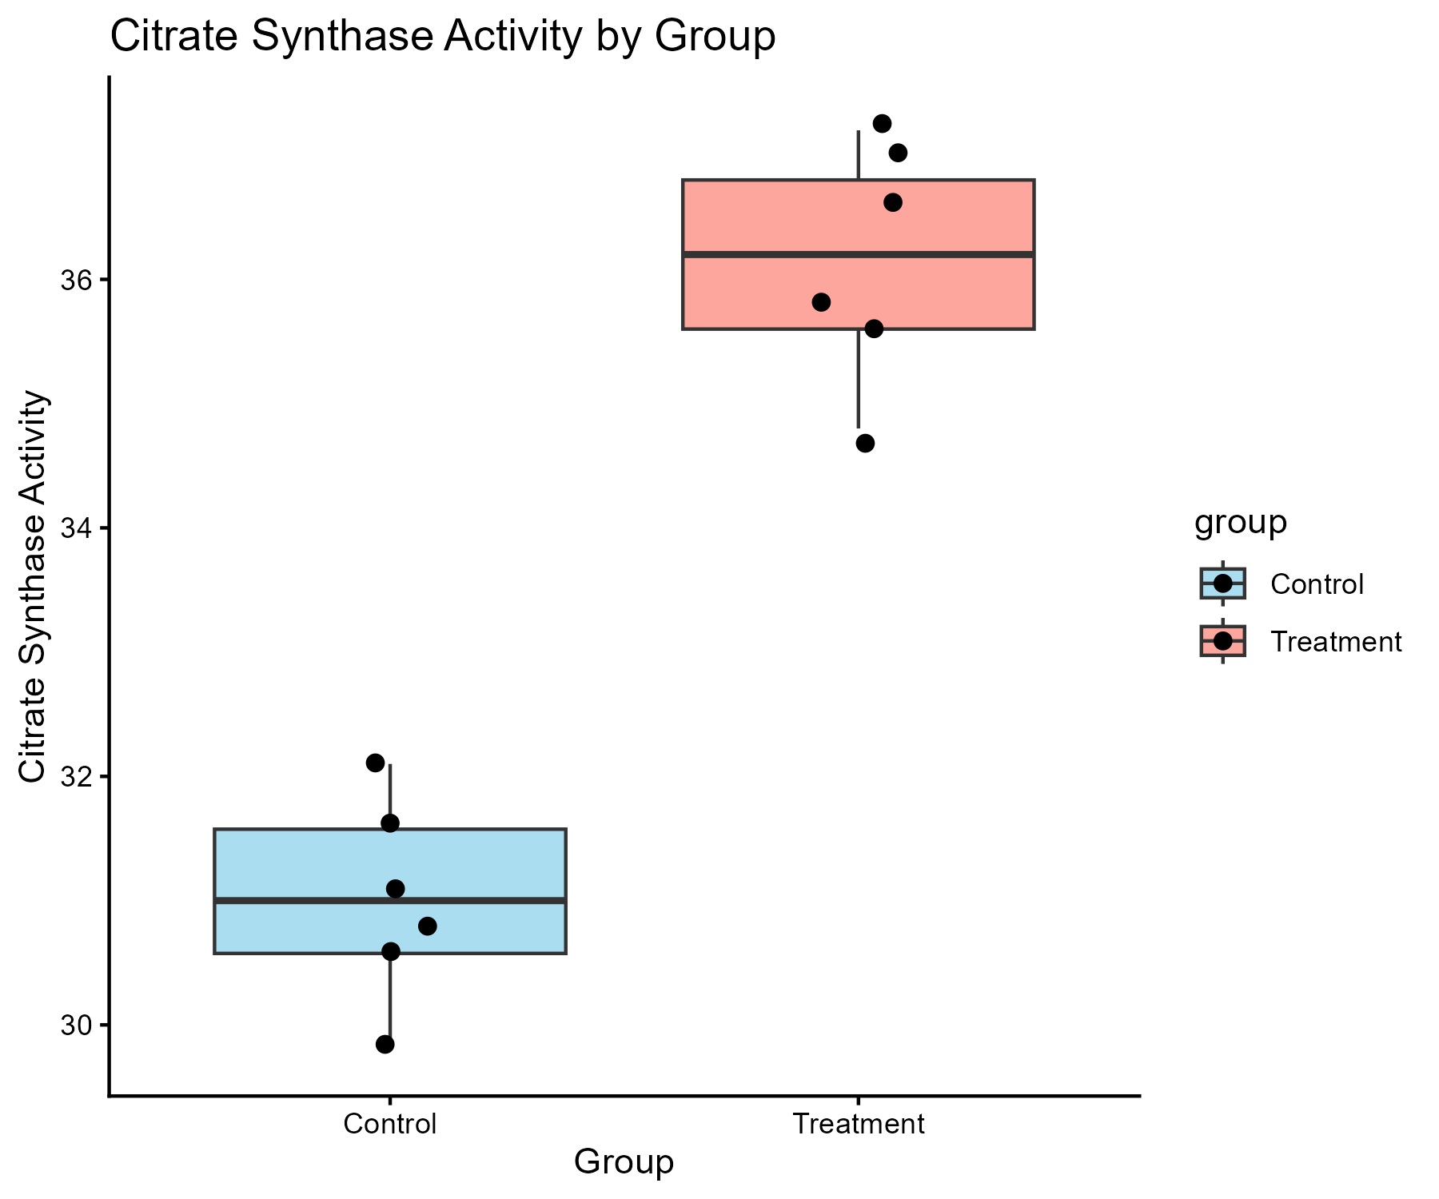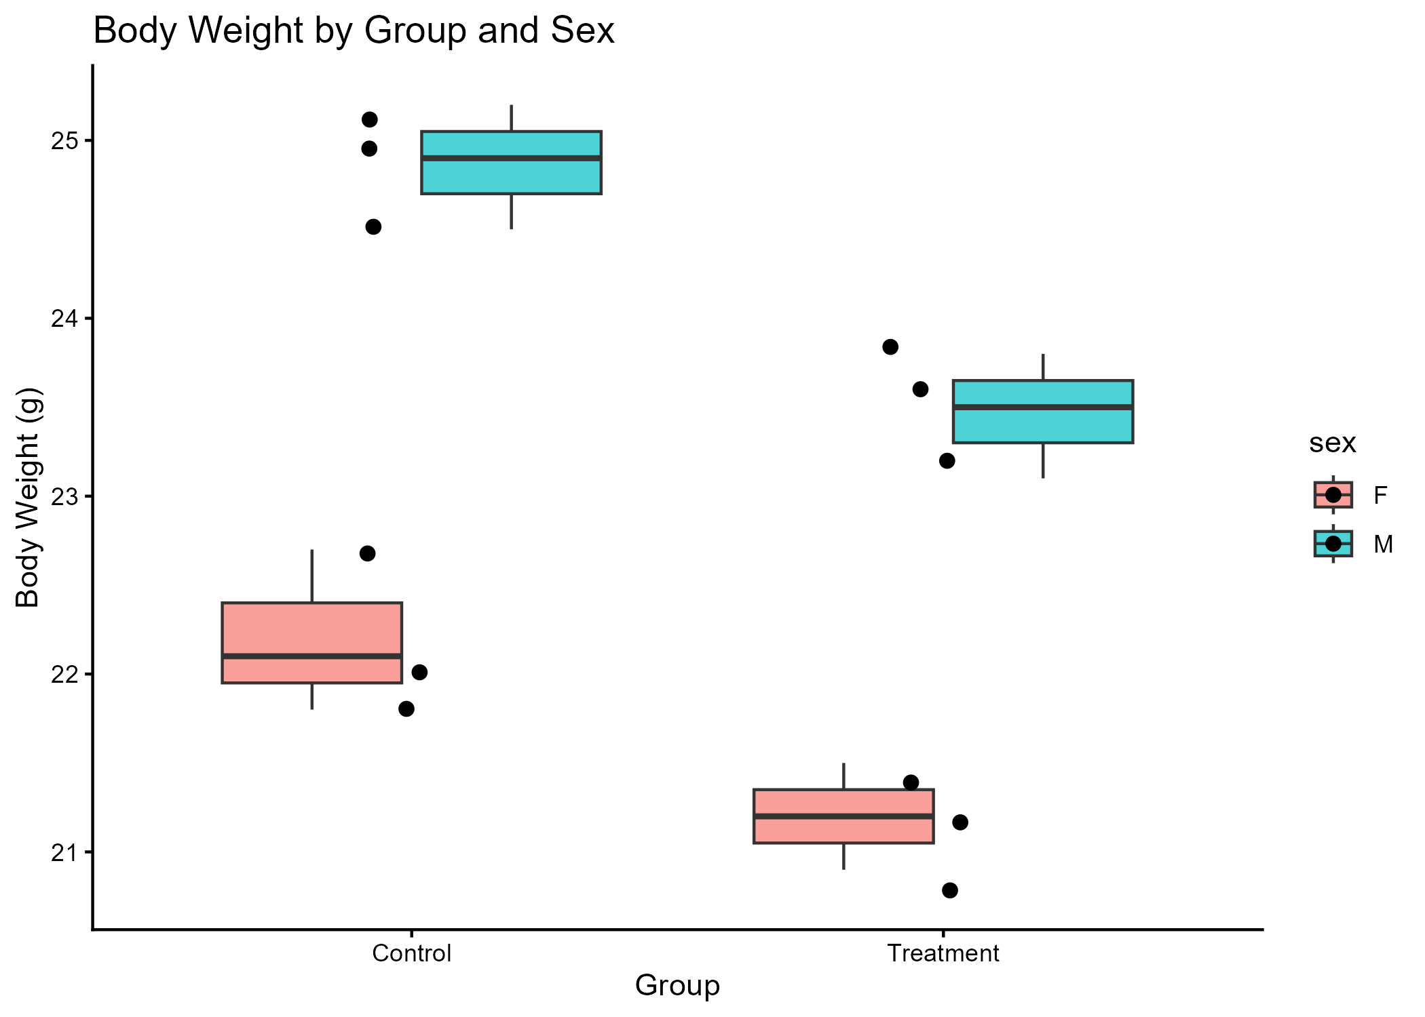

4. Install agent and create your first prompt log entry documenting AI use and verification.
4.1 Github:https://www.github.com/ (Create your account and repository for your homework submission). You need an account and a repository for homework submission (following the pattern: Bioinformatics_homework_Yourname_ID). You also need personal access token in together with repository link to activate your EasyMultiProfiler-web account.
4.2 Hermes-agent: https://github.com/NousResearch/hermes-agent (Install agent for coding) and Hermes WebUI (https://github.com/nesquena/hermes-webui)
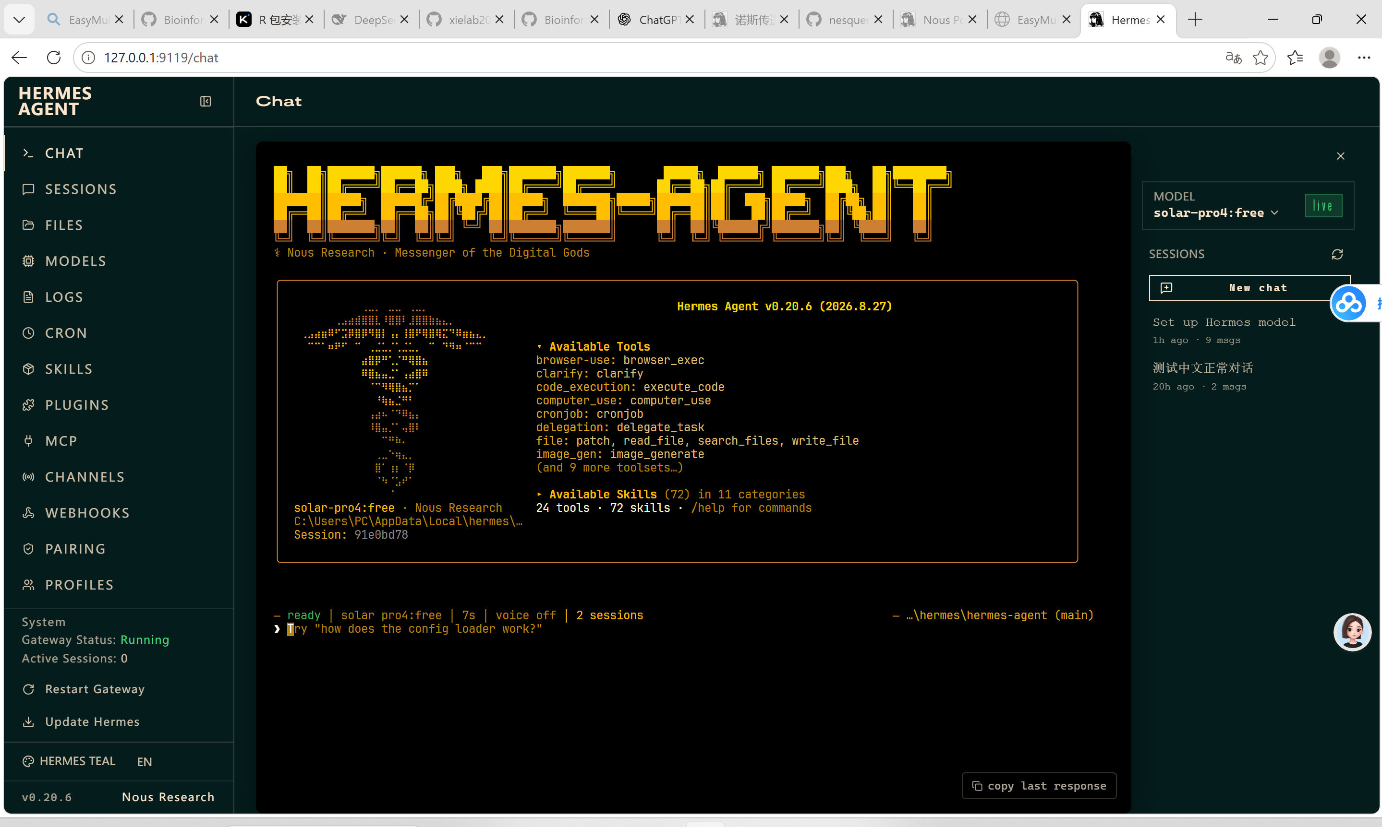
4.3 Codex: https://chatgpt.com/codex/ (Install for coding and agent)
4.4 Deepseek API: https://platform.deepseek.com/usage (Top up ¥10 for agent set and switching to LLM accessed only on SUAT campus) or NVIDIA API

5. Install EasyMultiProfiler and EasyMultiProfiler-Web for multi-omics data analysis and homework submission (You can use Hermes or Hermes WebUI to complete the installation step)
EasyMultiProfiler: https://github.com/liubingdong/EasyMultiProfiler
EasyMultiProfiler-Web: https://github.com/xielab2017/EasyMultiProfiler-Web
